**Practice Problems for Multiple Linear Regression**

1. Consider a dataset of movies that has the US ticket sales (in millions), along with the movie budget (in millions), the rating (number of stars), and the run time (in minutes). Building a model for US ticket sales using these predictors in Stat crunch returns this output:

a) What is the regression equation, based on the above output?

b) Using your answer from part (a), predict the US ticket sales if the movie budget is $32 million, the rating is 3 stars, and the run time is 100 minutes.

c) Is this model statistically significant at the 5% level of significance? Where can you find the information you need from the output?

d) Explain what variable(s) (if any) in this model are good candidates for being removed to make a simpler model?

e) What is the R2 value for this analysis, and how do you interpret it?

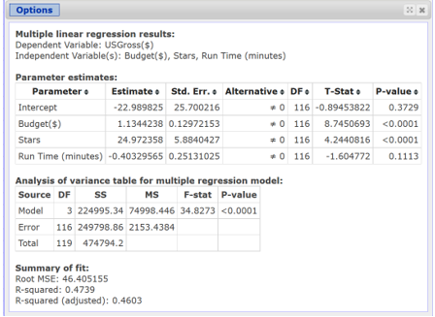

1. For the following parts, consider the model chosen in point (a) above.  
   (b.1) Is the model chosen a “good” model? Why? Discuss and precisely indicate which part(s) of the summary output you used.

(b.2) How can you interpret the estimated value for the intercept term of the model. Does it have any economic meaning?

(b.3) For each of the estimated coefficients of the independent variables in the model: (i) discuss the expected sign and check whether it is confirmed by the estimate;  
(ii) Provide the economic interpretation (if any) of the estimated coefficient;  
(iii) Discuss the statistical significance of the coefficient, indicating which parts of the summary output you used.

(b.4) Predict the number of Netflix subscribers in a country where: Monthly Price=8, Movies=4250, Price of Rival Platform=7.

Build a 95% confidence interval for this prediction. Explain your results.

(c) Netflix gives you a budget to improve the analysis above. Explain how you would employ the budget (e.g., buy new data, hire an analyst to run different models).

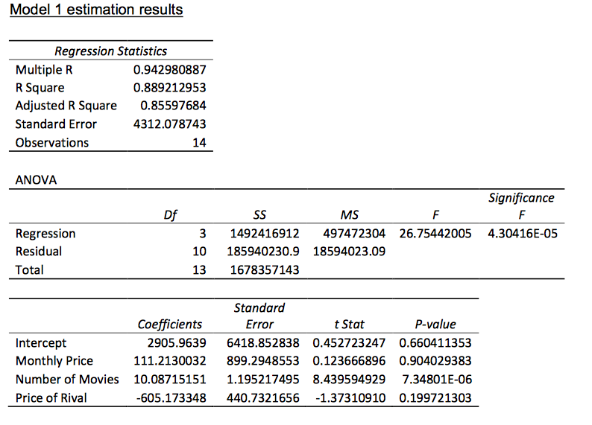

1. Study the Minitab regression output that follows. How many predictors are there? What is the equation of the regression model? Using the key statistics discussed in this chapter, discuss the strength of the model and the predictors.

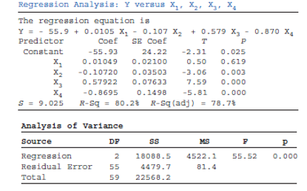

1. Study the Excel regression output that follows. How many predictors are there? What is the equation of the regression model? Using the key statistics discussed in this chapter, discuss the strength of the model and its predictors.

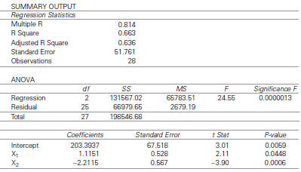

1. Test the null hypothesis that all of the regression parameters are zero at the 0.05 level and interpret the result for following anova output:

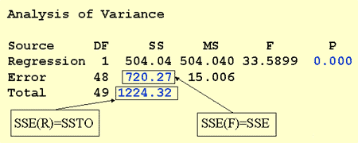

Can you conclude that there is a statistically significant linear association between lifetime alcohol consumption and arm strength?

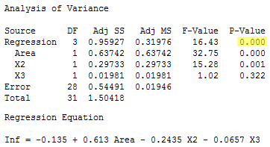

1. Study the following analysis of variance table, which was generated from a simple regression analysis. Discuss the F test of the overall model. Determine the value of F and test the slope of the regression line.

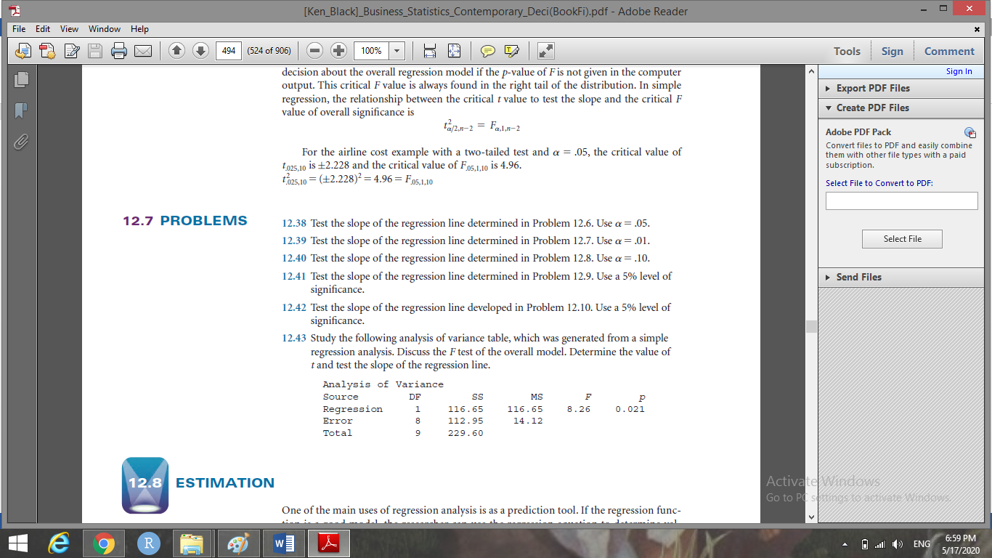

1. Study the following multiple regression output. How many predictors are in this model? How many observations? What is the equation of the regression line? Discuss the strength of the model in terms F. Which predictors, if any, are significant? Why or why not? Comment on the overall effectiveness of the model.

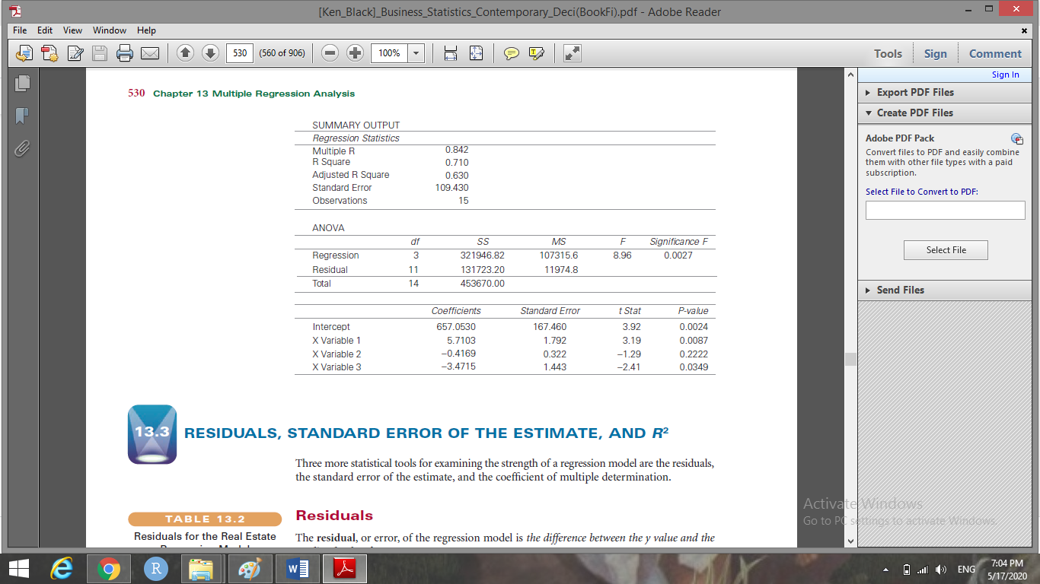

1. Displayed here is the Minitab output for a multiple regression analysis. Study the ANOVA table and the F ratios and use these to discuss the strengths of the regression model and the predictors. Does this model appear to fit the data well? From the information here, what recommendations would you make about the predictor variables in the model?

